**BPA- Bulldog Walk-a-Thon**

**Parents Invited On Campus 2-3p 03/29/19**

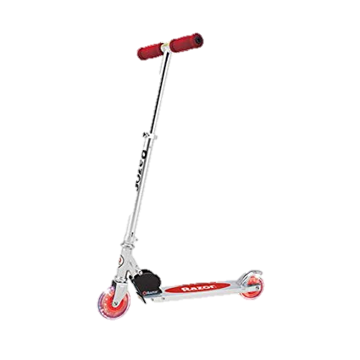**Pledge Collection Starts March 8th Due March 29th**

|  |  |  |  |  |
| --- | --- | --- | --- | --- |
| **Related imageTOP PRIZES**  **Top money earner will make the first selection for a prize that he/she wants. 2nd and 3rd place**  **money earners will make the next selections consecutively. Also applies to levels 4 and 5 selections. *Lifetime prizes apply until the end of the current school year.** | | | | |
| **1st Place**  **Razor Scooter + $10 Bulldog Bucks + Pizza & Kona Ice for Life*!** | | **2nd Place**  **Razor Scooter + $5 Bulldog Bucks + Kona Ice** | | **3rd Place**  **Razor Scooter** |
| **Level 1: $10+** | **$5 Bulldog Bucks + Jean Day** | | | |
| **Level 2: $25+** | **Personal Pan Pizza Gift Card + Choice of Stuffed Animal** | | | |
| **Level 3: $50+** | **Kona Ice Gift Card + 8-pack of Play Foam** | | | |
| **Level 4: $75+** | **Choice of Toy: Paw-Patrol Set, Stick Horse, Play-Doh Kit, Cooking Set, Weaving Loom, Tea Set, Toy Trucks/Cars, Splash Pumper, Jurassic Park Art Kit, OR Spider Man Hopper**  **OR Air Foam Disc Shot.** | | | |
| **Level 5: $100+** | **Choice of Toy: Fishing Pole, Snorkel Set, Pop-A-Pitch, Kitchen Set, Barbie Dolls, V-Tech Camera, Remote Control Car,**  **OR Air Player Ball Blaster.** | | | |
| **Winning Class**  **to Raise the most money** | **Ice Cream Bar in the Game Room**  **Build your own ice cream tower with toppings of your choice. Spend an hour in the game room with your friends playing classics like Uno, Candy Land, Battleship and foosball!** | | | |
| Top Runner for each Grade Level will Win a Prize | | | Image result for image pie in faceTop 3 Winners Pie Your Teacher or Principal in the Face at the Prize Ceremony! | |
| **School Goal**  **$1000** | **School-wide Glow Stick Disco Party in the Gym!** | | | |

**Funds will go towards the purchase of a pair of**

**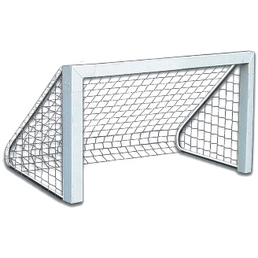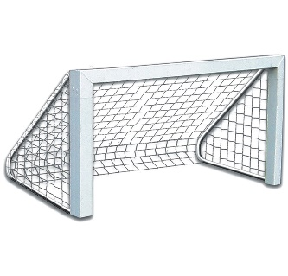****Soccer Goals for P.E. and After School Activities!**